Assignment 17.1

- Write a scala program to read a text file and print the number of rows of data in the document.

Creating a text file named “textfile.txt”

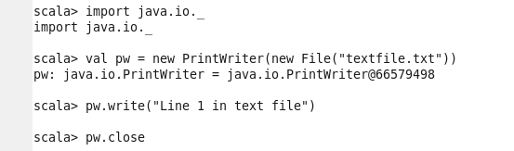

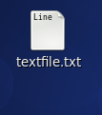

Added a line in text file created:

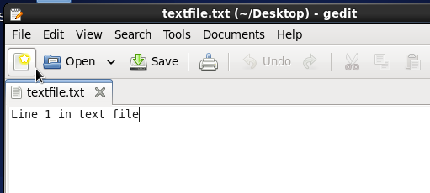

Adding few more lines in a text file:

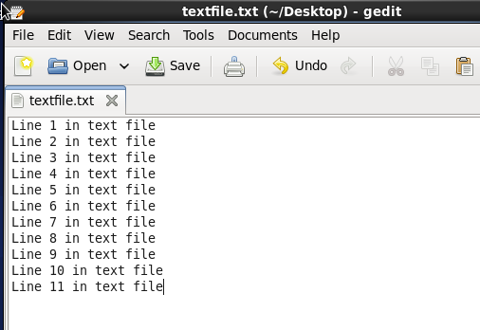

To print the number of rows data in the document:

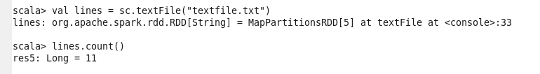

- Write a scala program to read a text file and print the number of words in the document.

Counting each words in a text file:

Saving words counted in a Output folder:

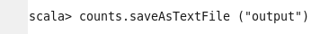

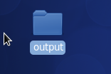

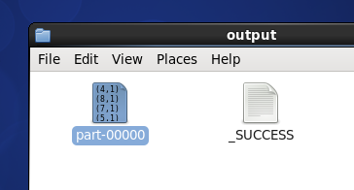

Below screen shows each words counted in a given text file:
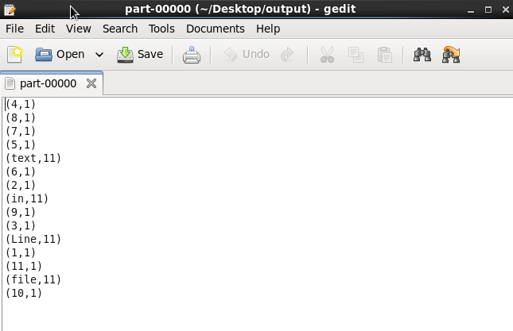

- Scala program to obtain total number of words present in a document:

Input file:

